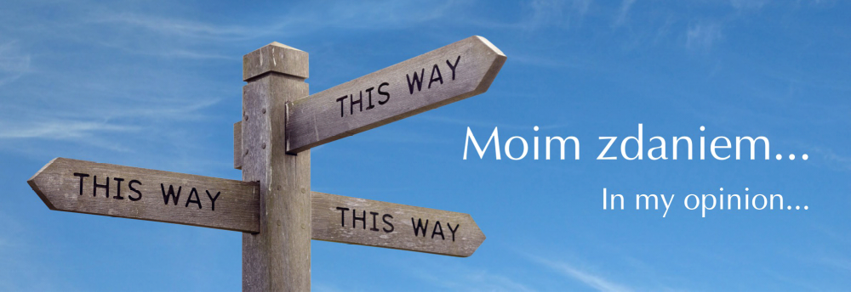

In My Opinion… Jewellery with a Message

11. Sandomierz

From the 5th of July 5 to the 1st of September 2019, the exhibition of the project "In My Opinion…" was held at the Regional Museum in Sandomierz. During the summer holidays it was seen by 18460 people! There was amazing response from the audience. As it is always in the case of the exhibitions of the project, the coordinators asked viewers to share their emotions (not to evaluate the design presented works, but the emotions that they arouse!) by sticking a red or green dot on the glass of the display case. This time there were so many dots that almost all the works were concealed. Museum staff said they did not remember such discussions evoked by any exhibitions. Visitors were not always in agreement with the authors’ opinions, but this is exactly what the whole project is about: about artists communicating with viewers through a three-dimensional, goldsmithing object. It worked out great.

12. Legnica

October is the time of the show at the Art Gallery in Legnica. The exhibition will be held from the 2nd to the 26th of October. The Art Gallery in Legnica is one of the most important places on the map of contemporary goldsmithing art and art jewellery. The finissage will begin at 6 p.m. on the 25th of October and it will end the celebrations of forty years of Legnica silver exhibitions. It is worth mentioning that as far as modern goldsmithing and jewellery are concerned, the run of exhibitions and competitions, started in 1979, is the biggest and longest-lasting project in the world! Such a jubilee we are planning to spend among a really big group of friends and sympathisers.

All the time new artists are sending their opinions in the form of jewelry. The project is evolving, and from a Polish exhibition it is becoming international; and not even European, but global, because there are participants from the USA, Argentina, Chile and Australia. For this exhibition we have prepared a 7th Supplement to the catalogue, in which new works, entered recently, are documented.

13. Zabrze

From November 2019 to January 2020, the exhibition will be presented at the Municipal Museum in Zabrze. In recent years, contemporary jewelry has rarely been shown in Upper Silesia, although in this region there are artists who make very interesting projects with black coal there is a dynamic secondary art school with a classes specialising in jewelry design (in Katowice), and finally there is the Museum in Gliwice with really rich and interesting collections. No wonder that Upper Silesia was a must on the tour route of our project.

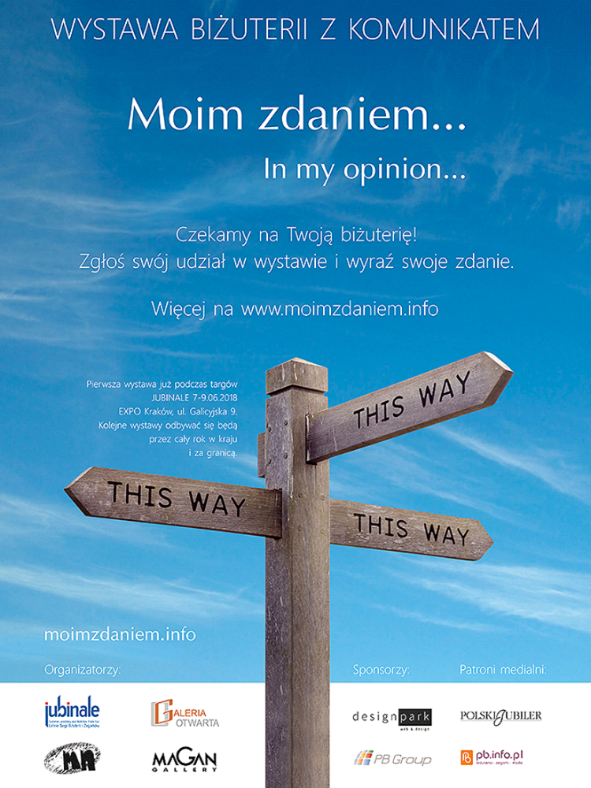

Coordinators
Marek Nowaczyk, Andrzej Pacak,
Mariusz Pajączkowski, Andrzej Sadowski



